Question 3

Given a network address of 10.0.0.0/24, divide it into 4 equal subnets.

Calculate the new subnet mask.

* 2 power n should be greater than or equal to the number of subnet required. Here it is 4, So the n value is 2. Therefore the subnet is 255.255.255.192/26
* Now calculate the number of host in each subnet. Which is 256-192 = 64

Determine the valid host range for each subnet.

|  |  |  |  |  |
| --- | --- | --- | --- | --- |
| Subnet | Network Address | First Host | Last Host | Broadcast |
| Subnet 1 | 10.0.0.0/26 | 10.0.0.1 | 10.0.0.62 | 10.0.0.63 |
| Subnet 2 | 10.0.0.64/26 | 10.0.0.65 | 10.0.0.126 | 10.0.0.127 |
| Subnet 3 | 10.0.0.128/26 | 10.0.0.129 | 10.0.0.190 | 10.0.0.191 |
| Subnet 4 | 10.0.0.192/26 | 10.0.0.193 | 10.0.0.254 | 10.0.0.255 |



Assign IP addresses to devices in Packet Tracer and verify connectivity.

* First configure the switch such that it has 4 Virtual lan for communication

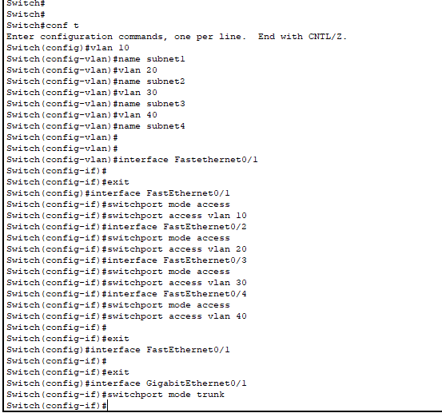

Once done, now configure the router to have 4 virtual LAN, also do encapsulation dot1Q for each sub-interface and assign ip for interfaces (first usable ip on the network)

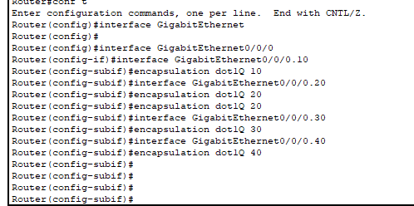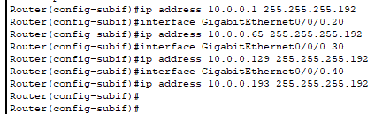\

Now if you try to ping the third sub class from the first one, you can successfully able to ping it

